Meet Children's Author
Adam K. Nelson
Author of A Night With St. Nick
2pm to 5pm, Saturday, December 11th
ABC Books – Springfield, MO
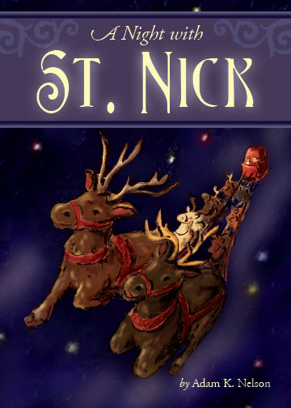
Get a book signed by the author
for all the kids on your Christmas list!


